PROGRAM TITLE
MARKETING AND OPERATIONS

PROCESS TITLE
Cargo Operations

- SCOPE

This policies and procedures manual establishes policies, systems, procedures and controls on cargo operations. All duties and responsibilities stated in this manual are not exclusive to the personnel’s designated responsibilities in this process title.

- OBJECTIVES

- To establish general guidelines on procedures on trucking, loading and unloading of vessel operations.
- To ensure proper controls, monitoring and documentation are in placed over cargo operations.
- To clearly define the duties and responsibilities of all personnel involved in this process title.

- PERSONNEL INVOLVED

  - Truck Driver

    - Responsible for the weighing, loading and delivery of cargoes to vessel, consignee or other designated receiver.
    - Obtains Authority to Load (ATL) from Operations Department.
    - Prepares and issues delivery receipt (DR).

  - Quarter Master

    - Check completeness, inspect and count cargoes loaded/unloaded in vessel.
    - Update cargo monitoring log during loading/unloading activities.

  - Chief Mate

    - Prepares the following:
- Notice of Readiness (NOR)
- Notice of Completion (NOC)
- Statement of Facts (SOF)
- Bill of Lading (BOL)
    - Obtains vessel inspection report, if any.
    - Ensures proper cargo stowage (trimming and piling of bagged cargoes).

  - Trucking Manager

    - Receives notice of booking from Operations Manager and forward details of delivery to Trucking Supervisor.
    - Responsible for overall trucking operations.

  - Trucking Supervisor

    - Checks availability and status of trucks.
    - Notify and give instructions to truck drivers and helpers.
    - Responsible for dispatching, giving instruction and monitoring of truck drivers and helpers.
    - Updates Truck Dispatching and Monitoring Report.

  - Operations Manager

    - Responsible for overall cargo operations including loading or unloading of vessel.
    - Approves Out-turn Summary.

  - Operations Supervisor

Checks and reviews completeness and accuracy of Out-turn Summary and its attachments.

  - Operations Supercargo/Staff

    - Receives duly accomplished accountable and other business forms (i.e., DR, CRD, CID, WT, ATL, BOL, NOC, NOR, SOF, etc.)
    - Prepares Out-turn Summary with complete attachments.
    - Forwards Out-turn Summary with complete attachments to Operations Department for proper checking, review and approval prior to endorsement to Billing and Accounting Department.

  - Accounting Staff

    - Prepares Statement of Account (SOA) upon receipt of duly accomplished Out-turn Summary with complete attachments.
    - Updates and maintains the sales journal and subsidiary ledger for accounts receivable

- KEY TERMS

  - Consignee – person/entity entitled to receive the cargoes delivered. Basically, the receiving party.
  - Gross Weight – weight of a loaded truck.
  - Net Weight – the difference between gross weight and tare weight.
  - Shipper – person/entity who delivers the cargo to consignee. Basically, the sending party.
  - Tare Weight – weight of an empty truck.
  - Vessel – ship used as a means of transportation of cargoes on water.

- POLICIES

  - Trucking

    - The warehouse/vessel cargo in-charge shall ensure that only trucks with duly approved authority to load (ATL) are loaded with cargoes.
    - All trucks shall be weigh prior to loading (i.e. tare weight) and after loading but before delivery (i.e. gross weight). The estimated cargo weight shall be determined by deducting the tare weight from the gross weight (i.e. net weight).
    - The operations in-charge shall check the reasonableness of the estimated cargo weight declared per weighing ticket by reference to standard average weight of similar type and quantity of cargoes loaded on trucks. Reasonableness of estimated cargo weight shall be determined both on a per truck and totality level.
    - Only good cargoes shall be accepted and loaded to trucks for delivery.
    - Appropriate cargo protective materials shall be made readily available in case of sudden inclement weather conditions while on road.
    - The operations in-charge shall monitor the number and progress of cargoes delivered by trucks and must ensure that the same are duly delivered to, received and acknowledged by the receiving party.
    - The use of mobile communications device or other electronic devices while driving, for whatever purposes (i.e., to write or read texts, make or receive calls, surf the internet, etc.), is strictly prohibited except in emergency cases. Provided, that such was done through a hand-free device using either speaker phone, earphones and microphones or other similar devices which will not affect or distract the line of sight of the driver. Driving speed shall also be taken into account.
    - Smoking or drinking while driving or under the influence of intoxicating liquor or drugs is strictly prohibited.
  - Loading/Unloading of Vessel

    - The Master shall have the authority to stop or resume the operations anytime as necessary and shall document the reason in the Statement of Facts.
    - Loading or unloading of cargoes shall be perform on time and within the date needed by the consignee to avoid delays.
    - Only good cargoes shall be accepted for delivery to consignee. Damaged, infested or wet cargoes shall be properly identified, segregated and return to the shipper. A report (e.g., report on damaged cargoes) shall be made in writing as to the type and quantity of the returned cargos and remarks thereof. Any replacement must be fully accounted and duly documented against returned cargo, if any.
    - Cargoes to be loaded onboard should be within the safe working loads or capacity of the cargo-handling equipment as well as with the total volume to be loaded are within the maximum load capacity of the vessel.
    - The Chief Mate must ensure that the vessel and its cargo-handling components (e.g. stowage, hatch cover, crane, etc.), is in good working condition and that the vessel is free from insects, pests and other elements or factors that could affect the cargo loaded onboard.
    - The Chief Mate must also ensure that all cargoes are fully loaded intact in accordance with the shipper’s declared quantity, weight or volume.
    - For cargoes loaded on board that cannot be measured individually by quantity but in aggregate in terms of weight, an objective and reliable estimate thereof shall be determine and copy of basis of calculation shall be obtain. (e.g., draught survey report)
    - A Mate’s Receipt shall be issued by the Chief Mate in cases when cargoes loaded on board are measured based on shipper’s count and that no representative of the Company was present or involved during the count. In no way shall the Mate’s Receipt be treated as a substitute for the Bill of Lading (BOL). Such document constitutes only as a provisional receipt until a final Bill of Lading is issued by the Company.
    - Only authorized personnel shall be allowed to operate inside the vessel.
    - All personnel involved must exercise the necessary diligence required when loading cargo onboard so as not to damage, contaminate, diminish or deteriorate the quality of the cargo being loaded.
    - All personnel involved in cargo operations must be physically fit and shall observed proper hygiene. Smoking and/or drinking inside the vessel and during operations is strictly prohibited. The Chief Mate shall properly report, in writing noted by the Vessel Master, to the Human Resource Department, personnel found to be under the influence of intoxicating liquor, drugs, or gambling during operations, shall be subject for disciplinary action. A copy of such report shall be furnished to the Operations Department.

  - Documentations

    - A uniform Out-turn Summary shall be prepared to summarize the details and supporting documentations for all types operations performed by the Company. At a minimum, the following shall be attached to the Out-turn Summary:

Type of Operations | Documentations
- Trucking delivery from shipper’s warehouse to vessel | - Delivery receipts (DRs)  - Warehouse issuance forms*  - Weighing tickets*  - Authority to load
- Shipping (from port of origin to port of discharge) | - Bill of lading  - Mate’s receipt (if applicable)  - Draught survey report (if applicable)  - Notice of completion  - Notice of readiness  - Statement of facts
- Trucking delivery from vessel to consignee’s warehouse | - Way bills  - Cargo receipts  - Delivery receipts  - Weighing tickets  - Warehouse receipt forms*  - Authority to load
- Cargo handling services (warehousing) | - Warehouse receipt/issuance forms

*Some client’s practice or standard form are that weighing or scale tickets are printed at the back of or consolidated with the warehouse issuance or receipt forms.

    - The Company shall comply with the specific documentations required per contract, per client or per regulatory bodies which is not usually prepared in the normal course of operations performed by the Company (i.e., Certificate of Random Sampling Report, Certificate of Vessel Spare Bags Manifesto, Letter of Protests, etc.)
    - All forms and documentations should be duly filled-out as to details, signed properly by the signatories above their printed full name and any alternations should be properly countersigned.
    - All activities conducted during loading and unloading of cargoes from vessel shall be properly documented in the Statement of Facts and a monitoring logbook shall be maintained to account for the total number of cargoes loaded/unloaded in the vessel.
    - Each vessel shall maintain a separate folder per voyage operations for filing of documents and other accountable forms and a monitoring thereof shall be made.
    - Copies of duly accomplished accountable forms and other documentations for distribution to other departments shall temporarily be kept by the Chief Mate during navigation or pending completion of voyage operations. Upon arrival to port of destination, the Chief Mate shall submit the documents to operations and retain vessel file copy.

- PROCEDURES

Trucking

Step No. | Activity | Personnel  Involved | Business  Forms
1 | Notify Trucking Manager of booking and details of delivery. | Operations Manager
2 | Receive notice from Operations Manager and forward details of delivery to Trucking Supervisor. | Trucking Manager
3 | Check availability and status of trucks. | Trucking Supervisor
4 | Notify and give instructions to truck drivers and helpers. | Trucking Supervisor
5 | Update Truck Dispatching and Monitoring Report. | Trucking Supervisor
6 | Prepare and issue three copies of Authority to Load (ATL). | Operations Coordinator/  Supercargo | Duly filled-out and approved ATL
7 | Acknowledge ATL and obtain two (2) copies. | Truck Driver | Duly filled-out, approved and acknowledged ATL
8 | Proceed to weighing area for determination of “tare weight”. | Truck Driver
9 | After weighing the empty truck, proceed to loading area (warehouse or vessel) and have ATL acknowledge by the cargo loading in-charge.  The cargo loading in-charge may either be the client’s warehousing in-charge or the chief mate of the vessel. | Truck Driver
10 | Acknowledge ATL and commence loading activities.  Cargo loading in-charge, truck drivers and helpers must ensure that all cargoes are properly and completely loaded to trucks. | Cargo Loading In-charge | Duly filled-out, approved and acknowledged ATL
11 | Proceed to weighing area for determination of “gross weight”. | Truck Driver
12 | Forward original copies of cargo issuance documents (warehouse issuance forms, cargo receipts, waybill, weighing or scale tickets, etc.) to Operations Supercargo. | Cargo Loading In-charge
13 | Receive original copies of cargo issuance documents. | Operations Supercargo
14 | Deliver cargoes to vessel, consignee or other designated receiving party. | Truck Driver
15 | Prepare and issue Delivery Receipt (DR) upon completion of delivery. | Truck Driver | Duly filled-out DR
16 | Acknowledge DR. | Vessel/  Consignee’s Representative | Duly filled-out and acknowledged DR
17 | Forward original copies of cargo receipt documents (warehouse receipt forms, receiving reports, weighing or scale tickets, etc.) to Operations Supercargo. | Vessel/  Consignee’s Representative
18 | Receive original copies of cargo receipt documents.  To “Preparation of Out-turn Summary” procedures. | Operations Supercargo

Loading of Vessels

Step No. | Activity | Personnel  Involved | Business  Forms
1 | Receive notification from Marketing Department. | Operations Manager
2 | Coordinate with Port Captain and notify shipper and port authorities w/in 24 hours from time of vessel arrival.  Port Captain to notify and give instructions to vessel crew. | Operations Manager
3 | Prepare four (4) copies of Notice of Readiness (NOR). | Chief Mate | Duly filled-out NOR
4 | Acknowledge NOR. | Shipper | Duly filled-out and acknowledged NOR
5 | Inspect vessel and commence loading activities. | Shipper
6 | Check completeness, inspect and count cargoes loaded to vessel.  For cargoes loaded to vessel that cannot be counted or measured in quantity but in terms of weight, obtain official report and computations from surveyor. | Quarter Master
7 | Update cargo monitoring log. | Quarter Master
8 | Seal vessel. | Shipper
9 | Prepare four (4) copies of the following documents:  - NOC  - SOF  - BOL | Chief Mate | Duly filled-out NOC, SOF and BOL
10 | Acknowledge NOC, SOF and BOL. | Shipper | Duly filled-out and acknowledged NOC, SOF and BOL
11 | Ship/deliver cargoes to port of destination. | Chief Mate

Unloading of Vessels

Step No. | Activity | Personnel  Involved | Business  Forms
1 | Coordinate with Port Captain and notify shipper and port authorities w/in 24 hours from time of vessel arrival.  Port Captain to notify and give instructions to vessel crew. | Operations Manager
2 | Prepare four (4) copies of NOR and forward copy of BOL. | Chief Mate | Duly-filled out NOR
3 | Acknowledge NOR and obtain copy of BOL. | Consignee | Duly filled-out and acknowledged NOR
4 | Unseal vessel and commence unloading activities. | Consignee
5 | Document unloading activities in the SOF. | Chief Mate | SOF
6 | Check and count cargoes unloaded from vessel. | Quarter Master
7 | Update cargo monitoring log. | Quarter Master
8 | Prepare four (4) copies of NOC. | Chief Mate | Duly filled-out NOC
9 | Acknowledge NOC, SOF and BOL. | Consignee | Dully filled-out and acknowledged NOC, SOF and BOL
10 | Obtain acknowledged BOL and forward duly accomplished accountable forms to Operations Staff. | Chief Mate
11 | Obtain duly accomplished business forms related to vessel loading/unloading operations. | Operations Supercargo

Preparation of Out-turn Summary

Step No. | Activity | Personnel  Involved | Business  Forms
1 | Receive duly accomplished accountable forms to be attached to Out-turn Summary as support. | Operations Supercargo
2 | Prepare Out-turn Summary with complete attachments. | Operations Supercargo | Duly filled-out OS
3 | Verify Out-turn Summary and attachments. | Operations Supervisor | Duly filled-out and verified OS
4 | Approve Out-turn Summary. | Operations Manager | Duly filled-out, verified and approved OS
5 | Receive and file duly accomplished copies of Out-turn Summary and attachments. | Operations Supercargo
6 | Forward copies of Out-turn Summary and attachments to Accounting Department. | Operations Supercargo
7 | Receive Out-turn Summary and prepare Statement of Account (SOA). | Accounting Staff
8 | Update Sales Journal (S) and subsidiary ledger for accounts receivable. | Accounting Staff

- FLOWCHARTS

  - Trucking

  - Loading of Vessels

  - Unloading of Vessels

  - Preparation of Out-turn Summary

- BUSINESS FORMS

  - Authority to Load

No. of Copies/color - 3
Explanation - This serves as authority of the truck drivers to accept cargoes for delivery to consignee’s warehouse.
Prepared/approved by - Operations Staff
Distribution - Copy 1 – Truck driver
Copy 2 – Chief Mate
Copy 3 – Operations Staff

  - Cargo Receipt

No. of Copies/color - 3
Explanation - This serves as receipt of cargo by trucks from cargoes unloaded from vessel for delivery to consignee’s warehouse.
Checked and verified by - Operations Staff
Distribution - Copy 1 – Truck driver
Copy 2 – Quarter Master
Copy 3 – Operations Staff

  - Way Bill

No. of Copies/color - 4
Prepared by - Operations Staff
Distribution - Copy 1 – Truck driver
Copy 2 – Accounting Department
Copy 3 – Operations Department
Copy 4 – Consignee

  - Delivery Receipt

Prepared by - Truck Driver
Acknowledged by - Vessel/consignee’s authorized representative
Distribution - Copy 1 – Vessel/Consignee
Copy 2 – Operations Department
Copy 2 – Accounting Department

  - Notice of Readiness

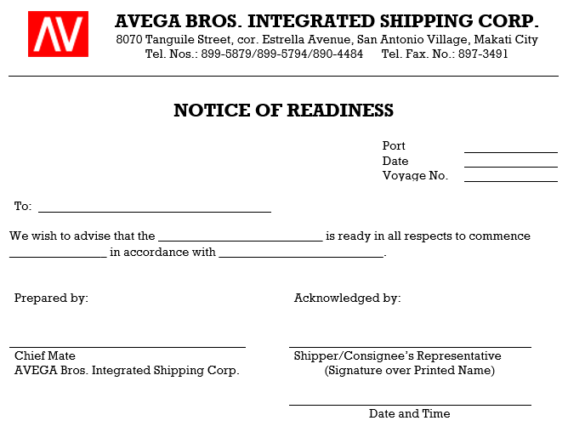

No. of copies - 4
Explanation - This is prepared to notify the shipper/consignee that the Company is ready in all respects to commence loading/unloading cargoes.
Prepared by - Chief Mate
Acknowledged by - Shipper’s authorized representative
Distribution - Copy 1 – Shipper/consignee
Copy 2 – Vessel
Copy 3 – Operations Department
Copy 4 – Accounting Department

  - Notice of Completion

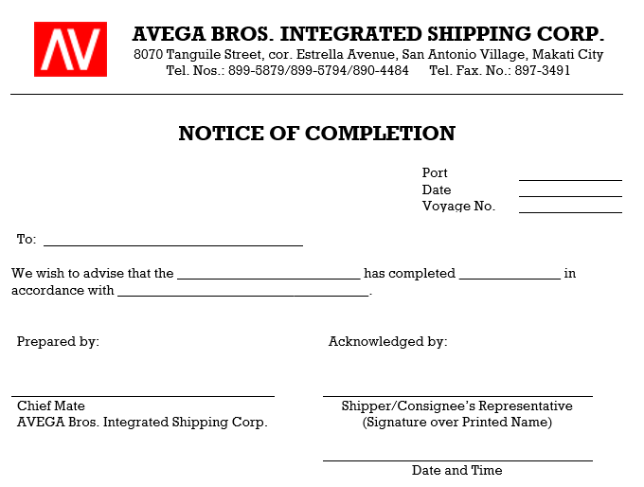

No. of copies - 4
Explanation - This is prepared to notify the shipper/consignee that the Company is ready in all respects to commence loading/unloading cargoes.
Prepared by - Chief Mate
Acknowledged by - Shipper’s authorized representative
Distribution - Copy 1 – Shipper/consignee
Copy 2 – Vessel
Copy 3 – Operations Department
Copy 4 – Accounting Department

  - Statement of Facts

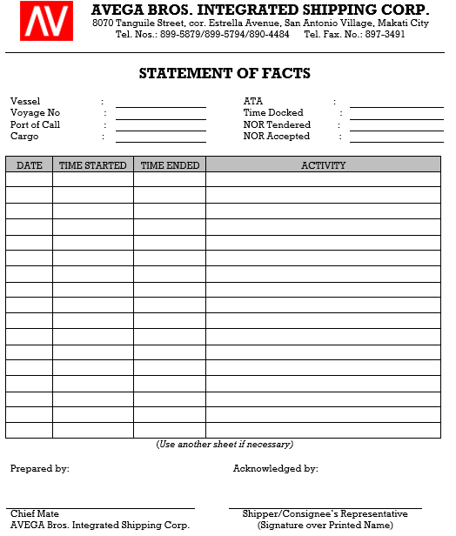

No. of Copies/color - 4
Explanation - This is to document the activities conducted during loading/unloading of cargoes.
Prepared by - Chief Mate
Acknowledged by - Shipper or Consignee’s Authorized Representative
Distribution - Copy 1 – Shipper
Copy 2 – Vessel
Copy 3 – Operations Department
Copy 4 – Accounting Department

  - Mate’s Receipt

No. of Copies - 4
Explanation - This is prepared in cases when the cargoes loaded on board are that of the shipper’s count in which no representative of the Company was involved during the count. This is, however, not a substitute for the Bill of Lading (BOL) but only represents a temporary receipt until a final BOL can be issued.
Prepared by - Chief Mate
Acknowledged by - Shipper or Consignee’s Authorized Representative
Distribution - Copy 1 – Shipper
Copy 2 – Vessel
Copy 3 – Operations Department
Copy 4 – Accounting Department

  - Bill of Lading

No. of Copies - 5
Explanation - This represents contract of carriage between shipper and the Company stating the details of the terms of delivery.
Prepared by - Chief Mate
Ship by - Shipper’s authorized representative
Received by - Consignee’s authorized representative
Distribution - Copy 1 – Shipper
Copy 2 – Consignee
Copy 3 – Vessel
Copy 4 – Operations
Copy 5 – Accounting

  - Out-turn Summary (Shipping)

No. of Copies/color - 3
Explanation - This summarizes the details and supporting documentations of shipping operations performed by the Company and serves as a basis for SOA preparation.
Prepared by - Trucking/Operations Staff
Distribution - Copy 1 – Operations Department
Copy 2 – Finance Department
Copy 3 – Accounting Department

- Out-turn Summary (Trucking)

No. of Copies/color - 3
Explanation - This summarizes the details and supporting documentations of trucking operations performed by the Company and serves as a basis for SOA preparation.
Prepared by - Trucking/Operations Staff
Distribution - Copy 1 – Operations Department
Copy 2 – Finance Department
Copy 3 – Accounting Department

- Outturn Summary (Handling)

No. of Copies/color - 3
Explanation - This summarizes the details and supporting documentations of cargo handling operations performed by the Company and serves as a basis for SOA preparation.
Prepared by - Trucking/Operations Staff
Distribution - Copy 1 – Operations Department
Copy 2 – Finance Department
Copy 3 – Accounting Department

- EFFECTIVITY

This Policies and Procedures Manual shall take effect upon approval and shall supersede any memorandum/SOP inconsistent with this Policies and Procedures Manual. Any changes to the manual shall comply with the policies and procedures indicated in the process title “Amendment of Manual”.

